幼兒接送人許可表
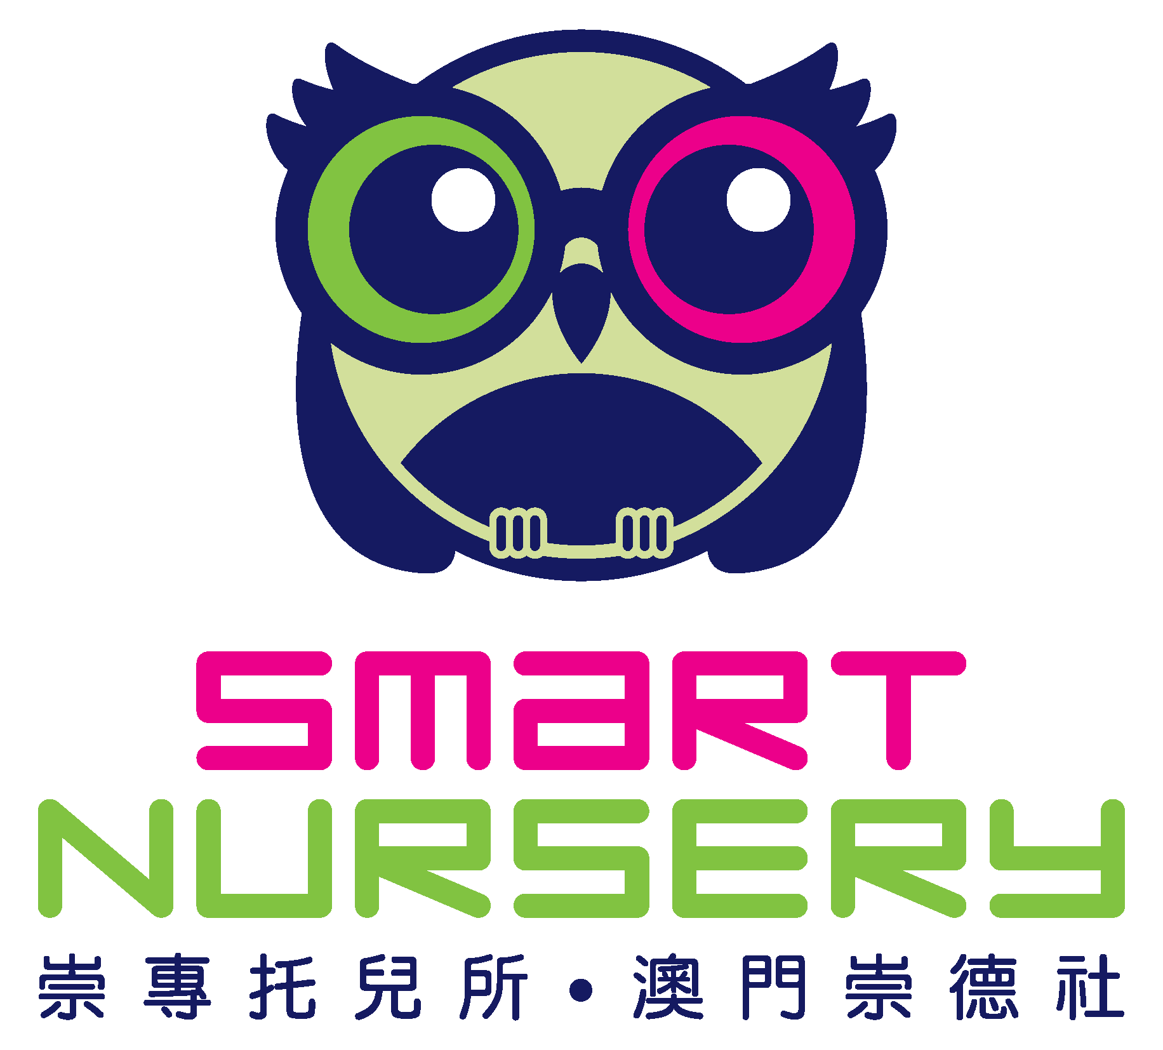
CHILD PICK UP AUTHORIZATION FORM

幼兒姓名Child’s Name: _____________________________ 班級Class: ____________________
主接送人Main Pick Up Person  名字Name: _______________________________  與幼兒關係Relationship: ____________________  身分證號碼ID No.: _________________________  手機號碼Mobile Phone No.: _________________ | 次接送人Another person who may pick up the child sometimes  名字Name: _______________________________  與幼兒關係Relationship: ____________________  身分證號碼ID No.: _________________________  手機號碼Mobile Phone No.: _________________
次接送人Another person who may pick up the child sometimes  名字Name: _______________________________  與幼兒關係Relationship: ____________________  身分證號碼ID No.: _________________________  手機號碼Mobile Phone No.: _________________ | 次接送人Another person who may pick up the child sometimes  名字Name: _______________________________  與幼兒關係Relationship: ____________________  身分證號碼ID No.: _________________________  手機號碼Mobile Phone No.: _________________

如上述接送人資料有任何更改，我將會立即通知崇專托兒所。
I shall immediately contact Smart Nursery and submit an updated Authorization Form if any.

___________________________
家長簽名Parent’s Signature
注意：
- 每位接送人須提供身分證或護照副本。Every pick up person should provide a copy of their ID or passport.
- 如果以上接送人或父母/監護人不能前來接幼兒離托，請及時致電本所或書面通知。在任何情況下，本所不會讓任何陌生人接走幼兒。Note: Any unauthorized person will be required to show proof of identification. Under NO circumstances will the child be released to anyone other than those listed above without CALLING or WRITTEN consent from the parents or guardian.

